Name ____________________________________ Hour ________
CHARACTER APPS
Directions: Make a list of at least eight apps that the protagonist might have on his/her phone. Draw an icon for each app on the smart phone template. On the back of the paper, write 2-3 sentences of evidence describing why each app would be used by the protagonist.
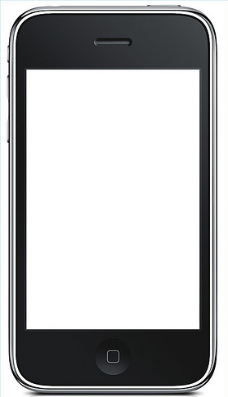

App List
App | Explanation (1-2 sentence minimum)

