Language Arts 6
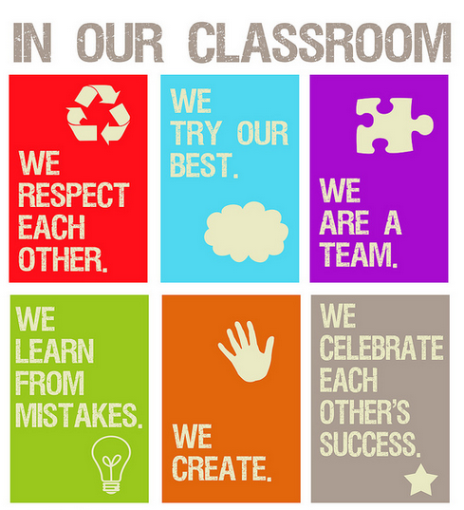
English Language Arts 6 - #01006
English Language Arts 6 is based on the Common Core State Standards (CCSS) for sixth grade. This course integrates listening, speaking, writing and reading with an emphasis on literary analysis. Students read narrative and informational text and analyze their structure, elements, and style. Vocabulary strategies are taught and reinforced through a variety of literature. Using the writing process and the six traits of writing, students write narrative and expository pieces, such as a personal narrative and the argumentative essay. The mechanics of writing, including sentence structure, spelling and grammar, are taught and reinforced through student writing. Students develop speaking and listening skills by participating in group discussions and oral presentations.
Stay Informed:

Accessing Weebly Web Page:
www.rochester.k12.mi.us
Click on ‘Schools’-‘Middle Schools’-‘West’
Click on “School Menu’-‘Classroom News’-‘Lovalvo’
Click on ‘Weebly’ link:
Languageartslovalvo7weebly.com
Accessing Holt McDougal Textbook:
http://my.hrw.com
Username: first initial + beginning 5 characters of last name + 4 digits of student ID + ‘h’ (example: jsmith1234h)
Password: holtstudents
Curriculum Common Core Standards site:
http://www.michigan.gov
A W.I.S.E. Warrior…

FAQ
What if I'm absent? Check the class website for daily assignments. Upon your return, pickup any missed handouts located in the classroom. You may always request your homework by email. All homework requests can be picked up in the office.
Can I turn in late homework? Assignments not completed on time will be recorded as missing and hold a 50% value. Once the assignment is turned in and graded, the missing assignment will be replaced with the value earned.
What supplies do I need for Language Arts?
-One 1” Binder
-A pack of 5 pocket dividers
-One durable 2 Pocket Folder
-Multiple Pencils/Pens/Highlighters/Coloring Supplies/Glue Sticks
-One composition Book

Classroom Donations Needed (Please and Thank You!):
Kleenex, Clorox Wipes, Hand Sanitizer, Highlighters,
Lined-Paper, Glue Sticks, Pencils

http://www.michigan.gov
Expresses a Positive Attitude
Includes Everyone
Works Hard
Shows up Prepared

GRADES
It is the students’ responsibility to check their grades regularly using the district website. Staying informed of their current course grade encourages individual ownership of a positive academic standing.
The goal is for all students to master the 6th grade language arts skills. Therefore, students will be provided with opportunities to redo assignments in order to prove mastery when appropriate.
BINDER
Since organization is an important element of academic success, the students will be required to maintain a binder containing their language arts assignments throughout the year. Students should expect occasional binder checks.
NOVELS
Identified below are the literature selections that may be used during this course:
The False Prince by Jennifer Nielson In a discontent kingdom, civil war is brewing. To unify the divided people, Conner, a nobleman of the court, devises a cunning plan to find an impersonator of the king’s long-lost son and install him as a puppet prince. Four orphans are recruited to compete for the role, including a defiant boy named Sage. Sage knows that Conner’s motives are more than questionable, yet his life balances on a sword’s point — he must be chosen to play the prince or he will certainly be killed.
The Watsons Go to Birmingham-1963 by Christopher Paul Curtis The ordinary interactions and everyday routines of the Watson’s, an African-American family living in Flint, Michigan, are drastically changed after they go to visit Grandma Sands in Alabama in the summer of 1963.
Esperanza Rising by Pam Munoz Ryan Esperanza Ortega possesses all the treasures a girl could want: dresses; a home filled with servants in Mexico; and the promise of one day presiding over El Rancho de las Rosas. But a tragedy shatters that dream, forcing Esperanza and her mother to flee to Arvin, California and settle in a farm camp. There, they confront the challenges of work, acceptance, and economic difficulties brought on by the Great Depression.
SUPPLEMENTAL MATERIALS FOR VIEWING
Throughout the year, students will view a few videos that enhance the literary genres studied in class. Viewing is a part of the State of Michigan’s Grade Level Content Expectations. The following videos complement our study of genres and will be considered for viewing:
Hoot, Tangled, Enchanted, A Series of Unfortunate Events, Trolls, Inside Out, Tuck Everlasting, Bridge to Terabithia, Ferngully, Hoodwinked, American Legands, Eragon, Princess Bride, Anastasia, The Watson's Go to Birmingham, How to Train Your Dragon, McFarland USA, The Lorax, The Lion King, Flipped, Boy Meets World, Big Hero 6, My Friend Martin, Soul Surfer
READING CHALLENGE
One of the pillars of our class this year is the Reading Challenge. This is derived from the successful work of Donalyn Miller, an educator from Texas and author of The Book Whisperer and Reading in the Wild. This challenge asks each child to commit an honest effort to completing a targeted number of books over the course of the school year, and more importantly, to always have a book that they are excited to read! In class, we will be working to incorporate this challenge in two big ways:

- STUDENT SELECTED NOVELS
Research shows that when students are given the freedom to choose their own reading material, they are likely to be more engaged, and their effort and motivation is increased. This results in increased learning and a strong commitment to reading. We are using this opportunity to inject student choice into the curriculum. For our units, we will still be using a model text to teach each specific skill; however, our students will practice those skills through the novels that they have selected - novels which they are excited to discuss, share and write about. Additionally, we will be working to weave this into other areas of the curriculum. Each day, our students are “face-to-face” with professional writers. We view this as a great opportunity to study how these writers use our language. Because of this opportunity, some of our grammar and vocabulary study will also draw from student selected novels.
- BUILDING COMMUNITY

Among the most important elements of a successful classroom is a strong community. One way that we build this in language arts is through our community of readers. Students are invited to share their favorite reading moments, not only through class discussion, but also through an invitation to get up and write on the walls. This invitation helps students share great books, exciting and moving moments in their reading, and new words that they discover with all of their peers across all hours of the day. It is important to us to not only build a community of readers at school but also at home, so that they can see the importance of reading in their daily lives. We would like to invite you and your family to join us in the challenge!

3 STEPS TO TAKE WITH A GRADE CONCERN
- Check your grade online
Check your grade online. Review each assignment grade and comments entered by the teacher.
- Talk to your child
Ask your child see his/her language arts binder so that you can review his/her assignments together. Take note of the corrections and notes written on each assignment.
- Student initiative
If questions remain, please have your child see me in person. I will be happy to go through his/her grade and make suggestions for improvement.
The move from fifth grade to sixth grade can be challenging. I am happy to work with your child through this transition period so that he/she can be academically successful in sixth grade.

-------------------Please cut and return to your language arts teacher ----------------------
We have read and discussed the information in the syllabus
Student Name: ______________________________ Hour: ______
________________________ ______________________
Student Signature

Parent Signature

Please provide an email where you would like to receive classroom updates.
_____________________________________________________________ Email address
_____________________________________________________________ Email address

